IMG_256

### **[点微]同城分类信息**

同城分类信息平台

**分类信息基础教程**

**第一步：登录微信支付商户后台**

**[https://pay.weixin.qq.com/index.php/home/login](https://pay.weixin.qq.com/index.php/home/login" \t "http://www.tomwx.cn/_blank)**

**微信支付说明：**[http://kf.qq.com/faq/140225MveaUz150107u2eu6b.html](http://kf.qq.com/faq/140225MveaUz150107u2eu6b.html" \t "http://www.tomwx.cn/_blank)

**第二步：后台设置微信支付参数**

[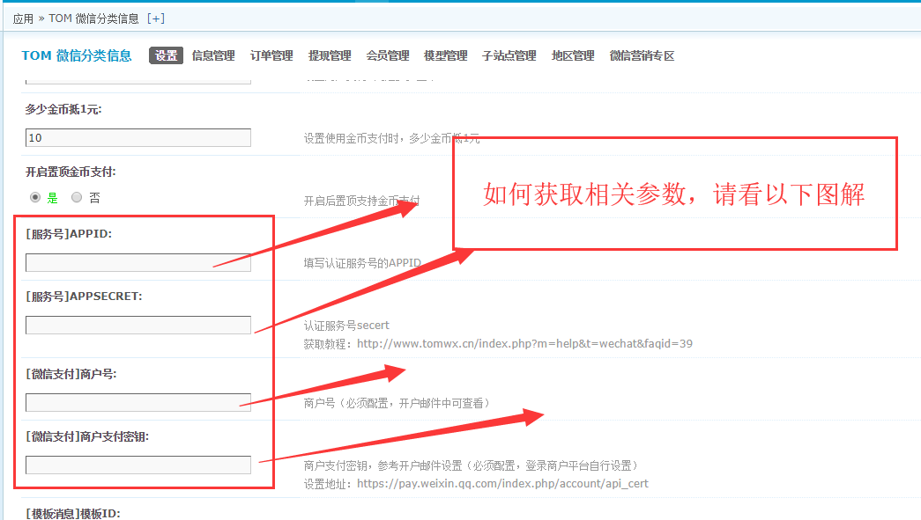](http://www.tomwx.cn/source/plugin/tom_editor/editor/attached/image/20180925/20180925110458_34224.png)

**1、截图的输入框第一个和第二个分别填写你的服务号APPID 和秘钥提交《不能弄错了》**

[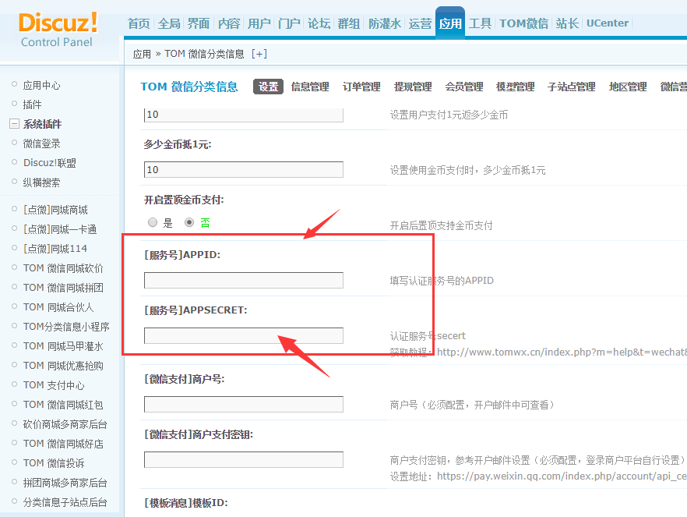](http://www.tomwx.cn/source/plugin/tom_editor/editor/attached/image/20180802/20180802095858_65913.png)

**获取AppID、AppSecret**

[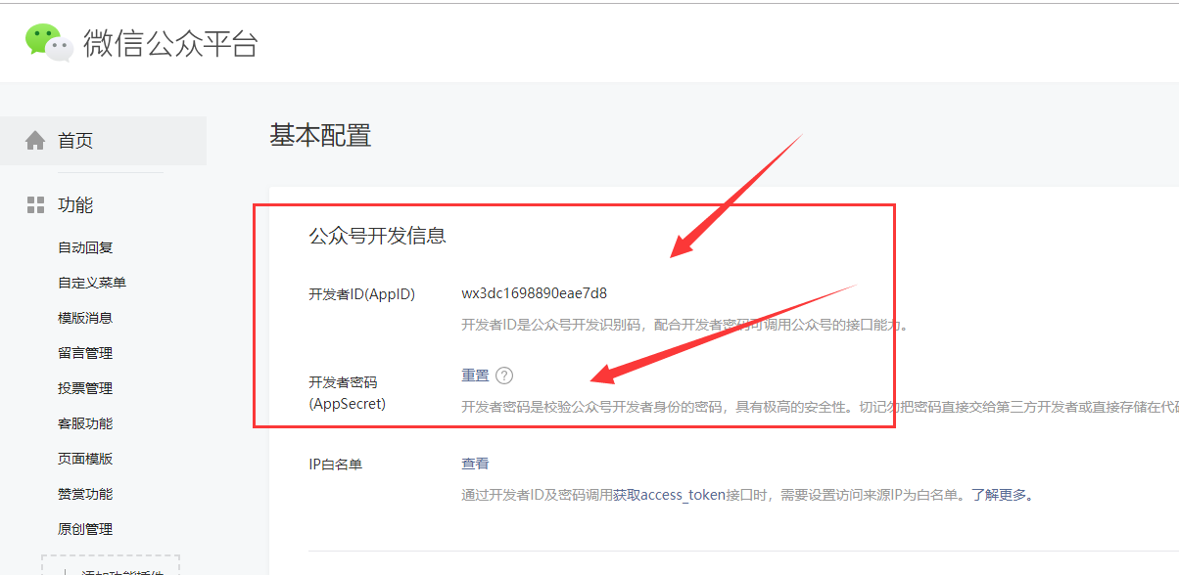](http://www.tomwx.cn/source/plugin/tom_editor/editor/attached/image/20180925/20180925112227_12573.png)

**2、截图的第三和第四输入框分别获取商户号以及支付秘钥**

[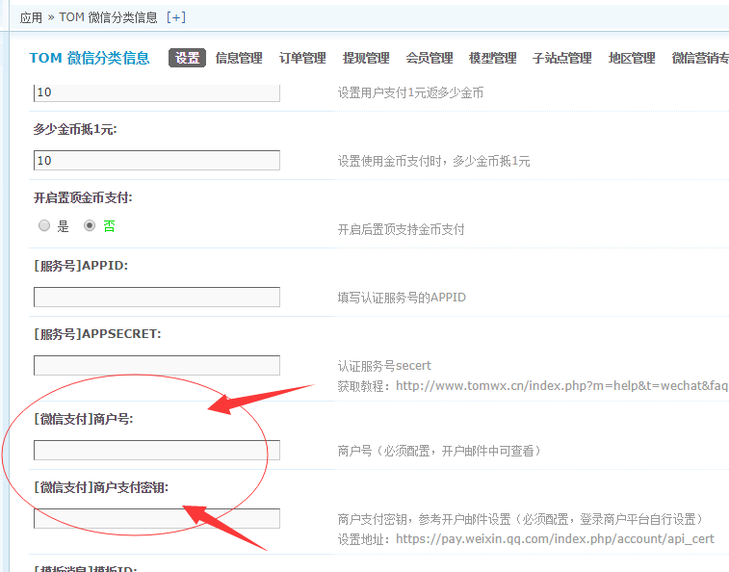](http://www.tomwx.cn/source/plugin/tom_editor/editor/attached/image/20180802/20180802095940_39330.png)

**获取商户号：**

[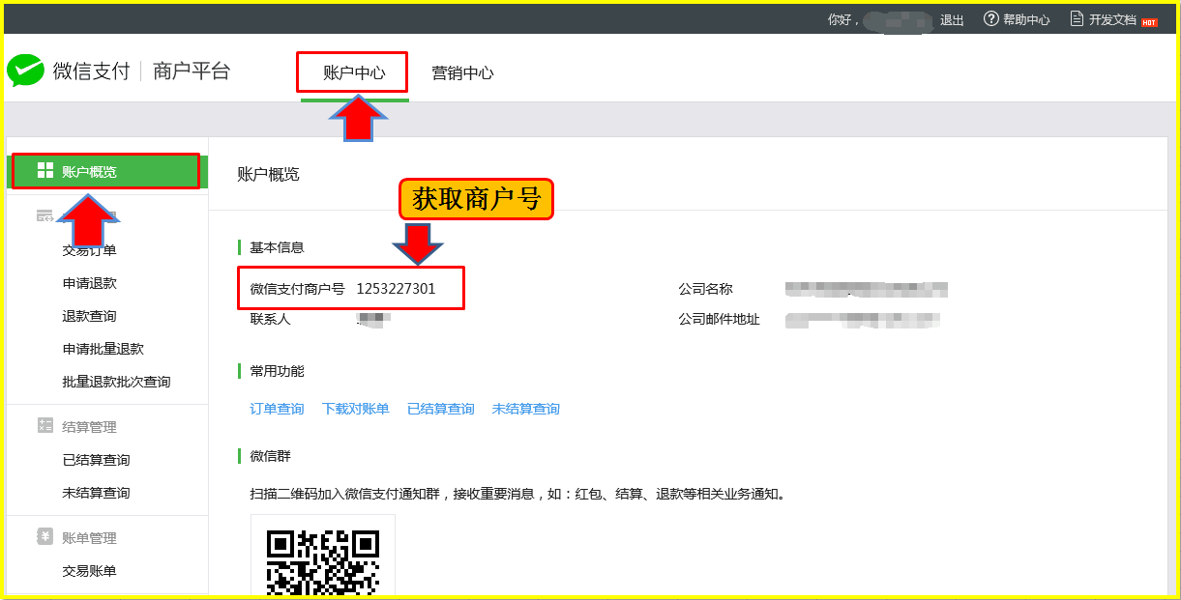](http://www.tomwx.net/source/plugin/tom_editor/editor/attached/image/20151029/20151029210809_95574.png)

**获取商户支付密钥**

[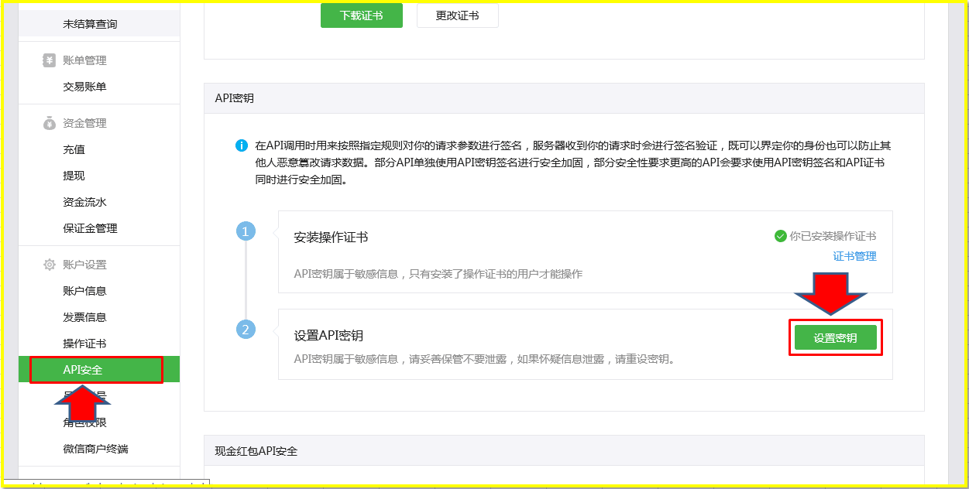](http://www.tomwx.net/source/plugin/tom_editor/editor/attached/image/20151030/20151030091943_94252.png)

[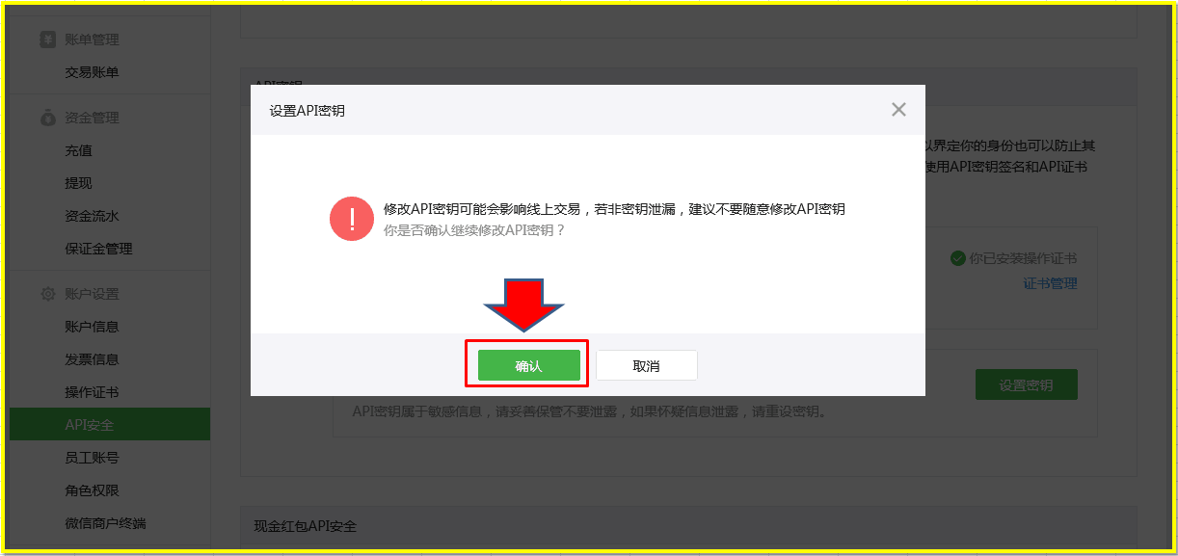](http://www.tomwx.net/source/plugin/tom_editor/editor/attached/image/20151029/20151029210915_18977.png)

[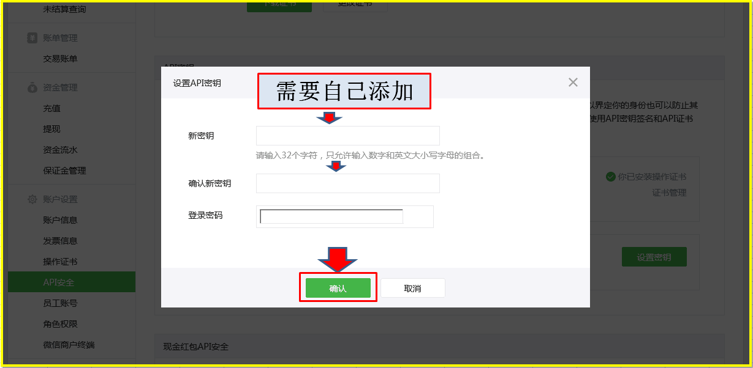](http://www.tomwx.net/source/plugin/tom_editor/editor/attached/image/20151029/20151029210946_54350.png)

**第三步：进入开发者中心，查看功能设置，找到：网页授权域名>> 修改**

[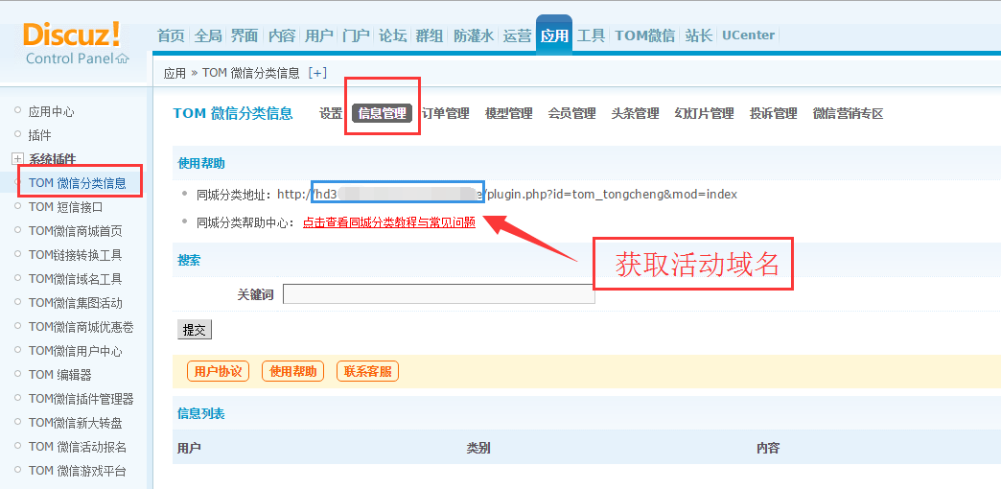](http://www.tomwx.cn/source/plugin/tom_editor/editor/attached/image/20170323/20170323042641_65014.png)

[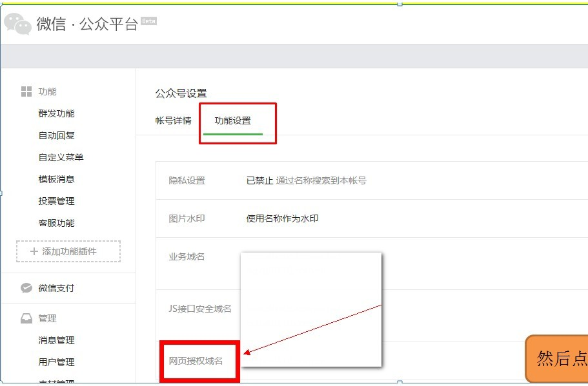](http://www.tomwx.cn/source/plugin/tom_editor/editor/attached/image/20161123/20161123092253_91913.jpg)

[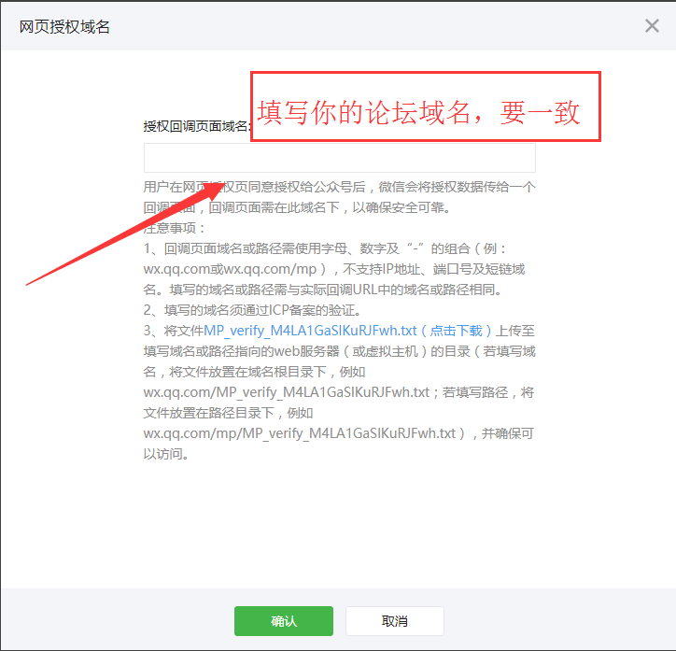](http://www.tomwx.cn/source/plugin/tom_editor/editor/attached/image/20170915/20170915034410_76874.png)

**第四步：安装启用用户中心插件并完成相关设置：《复制填写服务号的APPID 和秘钥提交，一致》**

[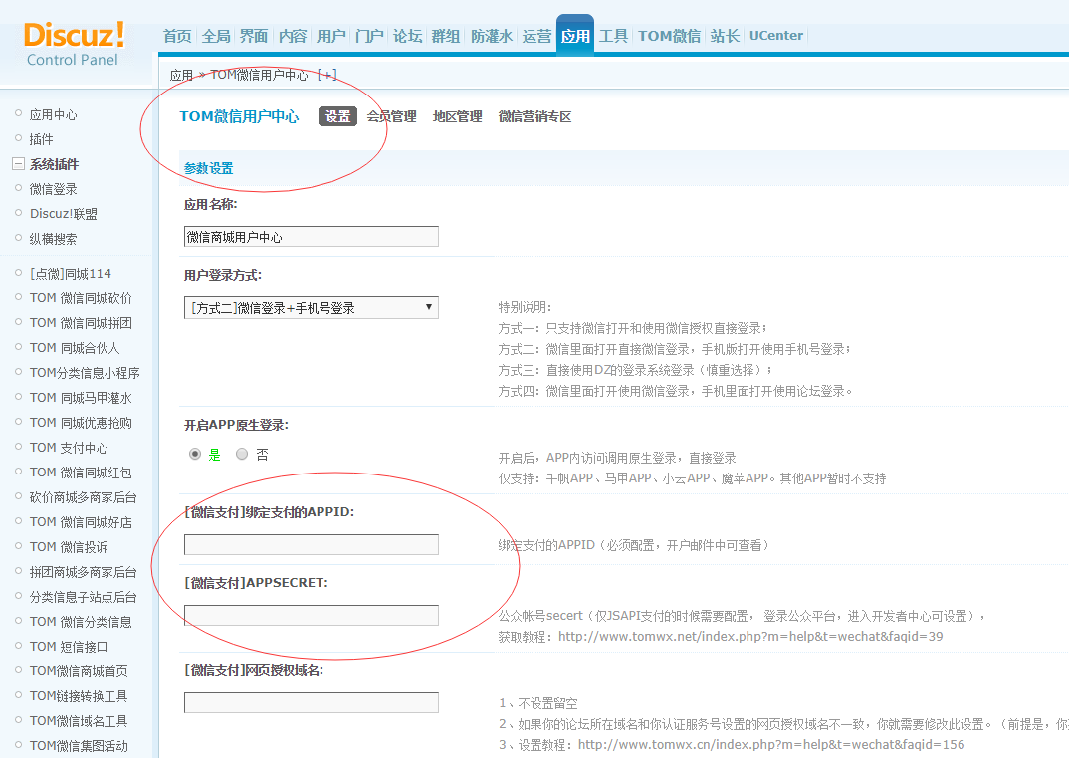](http://www.tomwx.cn/source/plugin/tom_editor/editor/attached/image/20180420/20180420112519_93527.png)

**最后一步：分类信息后台模型管理那边手动点击导入模型：**

[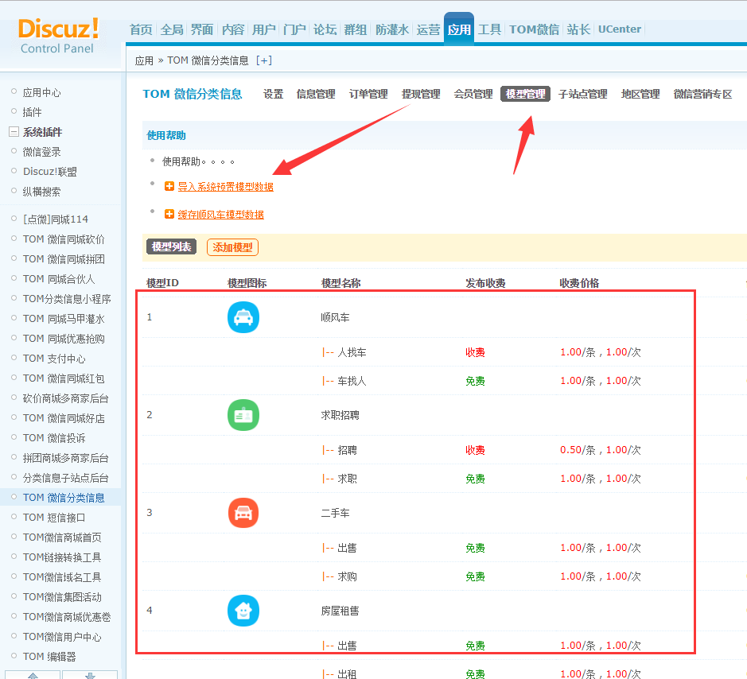](http://www.tomwx.cn/source/plugin/tom_editor/editor/attached/image/20180420/20180420113843_12515.png)

**第二个：这个位置就是你的分类信息地址，微信可以打开测试发布分类信息功能**

[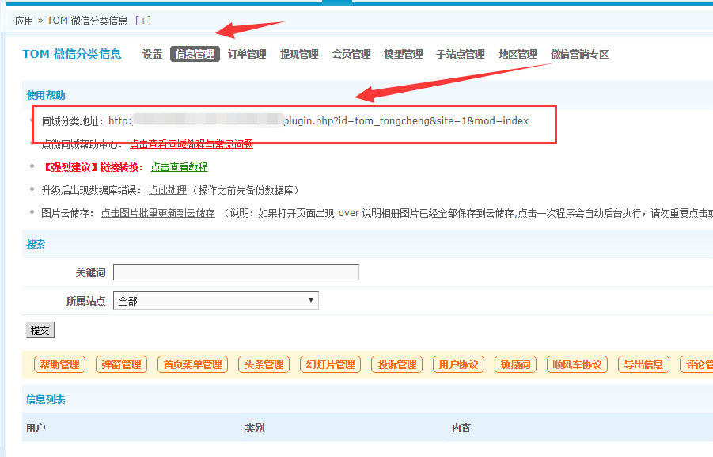](http://www.tomwx.cn/source/plugin/tom_editor/editor/attached/image/20180420/20180420114020_26870.png)

**警告：以上步骤一步不能少，都设置完毕后则可以测试分类信息功能**